Office hour/meeting log:

02/12/24: Dr Levy
- Look at the variance in tariffs by the four industry groups - you don't want it undone - ideally there would be correlation within the industry groups
- Statistical power
- If you add in the control, and it doesn't change estimates much - not a huge issue, suggests other confounders won't matter quite so much. So could control for industry productivity and see how it changes.
- Or - possible that the instrument for 'exogenous' tariff changes could just be from 1991 - 1997? (instrumenting for change from 1991 - 2001)

09/12/24: Professor Manning:
Give intro again to project: working on Bartik instrument idea – interested in employment outcomes – particularly if heterogenous by gender – seeing what the effect on women’s employment share is, (maybe also by women’s degree of exposure to trade/are male and female employment patterns converse?). In the midst of constructing my dataset – to hopefully run first stage as soon as possible.
- 1) Troubles with constructing my instrument: Four industry groups from 1991 data, will need to categorise at this level. Constructing weighted average tariff for the industry group: at first thought by 1991 output shares of each sub-industry, or through ASI data – number of workers engaged in the industry, however this is only available for small subsample of districts in the dataset – i.e. 1991. Using ASI entirely – covers 991 regions in total (by region code): no decomposition by gender

- Bit concerned in general of classification of industry groups: cultivator, agricultural labourer (works on another person’s land for wages in money or kind of share – has no risk in cultivation but works on another’s land for wages), household industry worker,
other worker (include all government servants, municipal employees, teachers, factory workers, plantation workers, those engaged in trade, commerce, business, transport, banking, mining, construction, political or social work, priests, entertainment artists, etc. In effect, all those workers other than cultivators or agricultural labourers or household industry workers, are 'Other Workers').
- 2001 is much more broken down with the ‘Other Worker’ industries – but it’s the pre-determined shares navigating simultaneity

^ Autor, Dorn and Hansen use manufacturing shares only – then have incomplete shares – include ‘missing share’ in regression 1 – s. (But all industries were affected by tariff changes – agricultural etc). Incomplete shifts – shifts that could only happen in a subset of industries.

If I combined the first two groups – agriculture and labour, and then had my fourth industry, then included the incomplete share.

Also more data – has division of main workers other than agricultural and cultivators broken down – but this is at the state level – the whole point is industry composition varies at the district level.

Reading Borusyak, Jaravel and Hull – requirement for shifts to be large in number – would this still be satisfied with me aggregating to such a large degree?

Why you need enough variation in industry groups: to capture district exposure sufficiently – i.e. say you have two industry categories heavily aggregated. Also statistical power – need variation in the treatment (instrument) to correctly identify effect.
- Need sufficient variation in tariff change component by industry group
- Pre-det industry shares having sufficient heterogeneity

From dataset:
- For pre-det weights, housing workers has little sd 0.02, very clustered around 0.02 – should I drop?
- Cultivators and agriculture well-spread, sd. of other workers: 0.182 – values somewhat clustered around 0.25.
- Pairwise correlations are also fine – negative correlation between agricultural industries and economic workers.

- Tariff patterns following 1997: uptick in almost all products 2001 tariffs higher than in 1997. Argued trade liberalisation decisions from 1997 (Ninth Plan) endogenous to industry characteristics – productivity. If industry productivity somehow significantly driven by a district/few districts, might be correlated with district outcomes – employment.

Not sure if this would violate exogeneity to local conditions, but districts quite large – if one district was really driving productivity – might not be. But looking at Borusyak, Jaravel and Hull assuming exogeneity of shocks; shocks need to be as good as randomly assigned to industries. Still need to go over.

Options considering:

Still going in similar directions by product using change from 1997 to 1991 as instrument – the final change from 2001 still by and large is reflected by change from 1997 to 1991.

Or from 1997 onwards, consider interacting with other countries changes – in the region.

- Will there significant enough variation of tariff changes across groups? I think so

- Measure of trade liberalisation: tariffs, correlated with other measures (anti-dumping, de-licensing, FDI flows). May consider utilising other measures as a robustness check later on – computing a composite measure might be difficult.

What does Topalova do?

Manning - consider using soil data, rainfall as instrument for what kind of crops might be used - if can access this by district
Need to account for degree of perishability of main agricultural good - proportion of agriculture that can be traded.

13/02/25: Michael Gmeiner
- Incomplete shares industries being assigned value of 0, creates endogeneity in the instrument value for locations. To control for this, I would have controlled for the sum of baseline shares but district FEs takes care of this. Q: would it be necessary to control for sum of shares in both periods? (potentially silly question – but we don’t mind that the treatment is endogenous?)

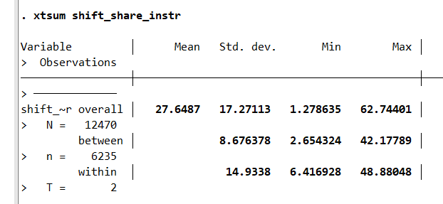
- (For shocks-as-instruments interpretation, too few shocks? I have employment data for 10 industry groups. Assumption for shocks being large/growing in number to ensure sufficient variation in coefficient.)
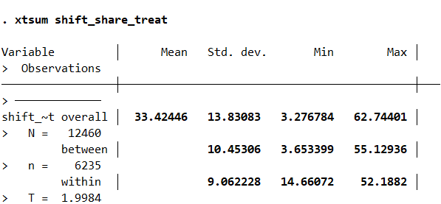

- Validating assumptions/shift-share design: Cannot regress on lagged outcomes – publicly available census data for India starts from 1991.

If I can find data on an industry covariate/characteristic running a balance test on the shifts (this can be national)

- Exposure-robust standard errors: Currently estimated at clustered region level – Adao et al: can potentially be a sig difference in rejection rates of null hypothesis when computing clustered SEs. Estimating shift-level regression - as a robustness check, how to compute with ssaggregate package?

- Worthwhile to still try and do consider

worth trying to compute?

- Employment as an outcome; not that much variation in employment within areas over time; i.e. standard deviation within a region across time: 0.04, mean employment: 0.4. Supervisor: not necessarily a key concern – would be a bigger problem if my estimates had large SEs too which made the confidence intervals large and it was difficult to accurately estimate anything.

21/02/25:
- First stage t-statistic: dataset is broken down; so for each region I have ‘rural’, ‘urban’, ‘total’ observations. ‘Total’ is the sum of rural and urban. When I run my first stage on the whole sample so the three obs per region, I get a first stage t-statistic of 253.61 (and then 346.20 when adding in the time trend for sum of shares)
- Go from 2556 observations to 852 – my standard errors become really large, sample size is reducing precision of first stage rather than instrument necessarily being less predictive (?). I’m losing a lot of the variation in the sample.
- My first stage has a large t-stat whichever 2 of the 3 I keep

But when I restrict to just ‘Total’, get a t-statistic of 6.74 (and then to 3.16 when adding the time trend? What does this mean for running my regressions?
Is it ok that I’m running my first stage on all observations? Or else I think I have a weak instrument problem :///
- When urban alone, my first stage is between 17.03 and 24.47, not ideal but still workable (would just need to change the angle some of my paper comes from). Rural alone is around 2.2 – 2.9 – quite bad
(F statistic is the square of the t statistic)

Look into this – maybe email Manning: to see how to restrict
Limited Information Maximum Likelihood
Anderson-Reuben test (pg 67 of the Gmeiner document)

Background 2 time periods, exog of the shocks

- Eventually grasped the incomplete shares control. Adding in a time trend for the sum of baseline shares into my regression; allowing this effect to change linearly in time periods – not enough to control for this once; want to control for the baseline sum of shares but then also the differential impact this has on period 2. (not the same as controlling for sum of shares in each period)
- E.g. ‘other services’ industry (incl finance, IT etc being high sum of shares and so instrument being smaller expect errors to increase over time – e.g. productivity rises (with educ), biases our estimates
Also see iPad notes

- The way I’ve done this: fixed effects capture effect of baseline in shares in first period. Gen a dummy for 2nd period obs. Then interact baseline shares with this dummy. Add this interaction into my specification to control for differential impact of sum of baseline shares in period 2 (district fixed effects capture for period 1). Is this right?
- Interestingly adding this in has flipped the sign of my coefficients, but now my results are more consistent.
Yes, this gives the same coefficient as a time trend this is ok :)

- Gender-specific shock regressions: Shares are calculated as e.g. the number of female workers in that industry/no. of main workers (initially it was no. of women in industry/no. of female main workers, but then ADH - equivalent to multiplying industry employment share with gender share in industry).
- Time trends for share of each gender in ‘other services’ (opposed to the sum of shares don’t want to remove the variation from different numbers of women working).

Time trend – control for sum of share more directly again – not an immediate issue with this, can try and estimate and see – do you like the SEs – is there sufficient variation?
The other control (of other services) would biased

- Using xtivreg for gendered IV regressions (two instruments does this compute 2sls? Before OH, try with other things, reghdfe something)

Limitation of having few industries:
Jacknife – ‘leaving one industry out’ each time, i.e. estimate with 9 industries – leave one out each time. If estimates don’t change significantly, you’re good.
Can show that variation is not asymptotically being driven

13/03/2025

